Procedural Guideline of the First Semester 2022
Undergraduate
Trimester Conversion
August 2022
Vice Presidency for Academic Affairs

Contents
Introduction 2
Vision 3
Mission 3
Strategic Goals 3
Key Characteristics of Trimester Conversion 4
An Overview of the Conversion and its Gains 4
Application Mechanism 4
Impact of Conversion on the Study Plans 5
Impact of Conversion on the Academic Schedules and Lectures Timetables 6
Impact of Conversion on Exams 8
Impact of Conversion on the Academic Procedures 9
Academic Procedures and its Rules 10
Dimensions of the Educational Process 18
Education Model at the University 18
Rules of the Educational Process during the Semester 18
Academic Calendar 19
Academic Advising Unit 20
Blackboard and its Rules 21
Exams and Grades 23
Grading System in the Common First Year 23
Evaluation and Grading System in the Colleges 24
E- Exam Systems 25
Banner 26
Internship for Undergraduate Programs 27
Communication Media with the University 28

Introduction

The Saudi Electronic University offers higher education that is built upon the best education models which are based on blended education’s applications and technologies. The university grants the degrees in programs and majors that are aligned with the job market’s needs. It strives to meet the development demands and supports lifelong learning to achieve its vision of integrating technology into the educational process; hence contributing to the digital transformation in the Kingdom. The trimester conversion in the Kingdom’s educational system is a change and development of the Saudi education system. This change impacts the educational ecosystem in form where the study duration and timetable have changed and in content also as the curricula has improved.

This guide is published by the Vice Presidency for Academic Affairs as part of the university’s efforts to meet the learning objectives and achieve the learning outcomes through providing an effective model of the trimester conversion, and to support the MOE initiative to develop the educational ecosystem as well as achieving the goals of vision 2030. In addition, it is intended to support Human Capability Development Program that aims to enhancing the educational environment, cultivating skills, and increasing the effectiveness of learning outcomes to fulfill the needs of the job market. This guide includes the study regulations during the first semester for the undergraduates’ programs as well as the rules and regulations concerning students throughout their university years.

Vision
To obtain a leading role in integrating technology into education; hence contributing to the national development.

Mission
To provide distinguished education for all society members who contribute to producing, sharing, and benefiting from knowledge to achieve development socially, culturally and economically.

Strategic Goals
Providing distinguished education that enables learners to achieve their academic and professional aspirations
Building a regional leading role in e-learning
Growth in digital innovation and technical entrepreneurship
Strengthening communication with local communities across the Kingdom
Achieving financial sustainability and expenditure efficiency

Key Characteristics of Trimester Conversion

An Overview of the Conversion and its Gains

It is a study system in which the academic year is divided into three semesters, each of which is 13-week long including final exams in addition to a possible summer semester of eight weeks. It is noteworthy that the trimester conversion helps wrap up the study material in one semester, which brings students closer to graduation and increases the efficiency of learning and expenditure as well as benefiting from the university's various resources.
Trimester system
The semester lasts for 13 weeks, 11 of which are academic weeks, one is an orientation week, and one week for the final exams.
Two- semester system
The semester lasts for 16 weeks, 14 of which are academic weeks, and the remainder is for the final exams.

Application Mechanism
The university considered the available options and the best international practices for the trimester conversion. Therefore, the university adopted a two-stage plan:

Transitional Stage: A Comprehensive Conversion Plan:
Key characteristics
- The possibility of modifying the credit hours of the courses and re-arranging the courses and prerequisites among the three semesters.

- Removing and adding courses and modifying the learning outcomes of the program and the courses.

Final output:
A study plan to be implemented at the beginning of the year 1445 AH
Key characteristics

- Maintaining the credit hours of the courses and re-arranging the courses and prerequisites among the three semesters.

- Modification of contact hours (by multiplying 5.1 * credit hours) without rounding the fractions.

Final output:
A study plan to be implemented at the beginning of the year 1444 AH

Impact of Conversion on the Study Plans

The course materials are distributed over 11 academic weeks in the study plans, the contact hours have been increased by multiplying the credit hours by 1.5. The contact hours for all undergraduate programs are amended, and the changes have been applied to the study plans of different programs. All courses of 3 credit hours are modified to 4.5 contact hours, and courses of 2 credit hours are modified to 3 contact hours.

Courses in the Common First Year are redistributed as follows:
Majors | Levels Before the Trimester Conversion | Levels Before the Trimester Conversion
Digital Media and Law | level 1 | level 1, level 2
All majors except Digital Media and Law | level 1, level 2 | level 1, level 2, level 3

Impact of Conversion on the Academic Weeks
The semester is divided into 13 weeks; 11 weeks for actual study, one week for orientation and one week for final exams.

Impact of Conversion on the Academic Schedules and Lectures Timetables

Below is the duration of lectures of three-credit hour courses
Before Conversion |  | After Conversion
50 min | X 1.5 | 75 min | Face To Face
50 min | X 1.5 | 75 min | Online
50 min | X 1.5 | 75 min | Asynchronous (Interactive)

Courses of 2 credit hours have been modified as follows:
Before Conversion |  | After Conversion
50 min |  | 50 min | Face To Face
50 min |  | 50 min | Online
 |  | 50 min | Asynchronous (Interactive)

The school hours were modified to start from 3:30 to 9:15 pm, and the total of shifts is 4, the courses of 3 credit hours are delivered in one of these shifts and its duration is 75 min:

Lecture 1 | Lecture 2 | Lecture 3 | Lecture 4
3:30 – 4:45 pm | 5:00 – 6:15 pm | 6:30 – 7:45 pm | 8:00 – 9:15 pm

The courses of 2 credit hours are delivered in one of these shifts and its duration is 50 min:

Lecture 1 | Lecture 2 | Lecture 3 | Lecture 4
3:30 – 4:20 pm | 5:00 – 5:50 pm | 6:30 – 7:20 pm | 8:00 – 8:50 pm

To ensure more flexible lecture times, lectures are available on Thursday for 100 min according to the following timing:

Lecture 1 | Lecture 2 | Lecture 3
3:30 – 5:10 pm | 5:30 – 7:10 pm | 7:30 – 9:10 pm

To achieve higher operating efficiency in getting the optimal use of the study halls and premises, the lecture days are divided based on the colleges as follows:

College | Face To Face Lectures | Online Lectures
College of Science and Theoretical Studies | Sunday and Monday | Tuesday and Wednesday
College of Administrative and Financial Sciences
College of Computing and Informatics | Tuesday and Wednesday | Sunday and Monday
College of Health Science

Impact of Conversion on Exams

Exams are considered the key means to assess students during the semester. The university adopts two stages of examination: the first stage is midterm exams and the second is the final exams. The examination systems are provided in two forms: offline computer-based exams and online exams, depending on the nature of the course. To ensure proper exam execution: the following conditions are adopted:
- Exams can be scheduled on Saturday if they do not conflict with a long weekend.
- Exam days shall be 6 days maximum for each level.
- Alternative exams of finals shall be conducted during the subsequent semester.
- Number of sessions:
  - 4 sessions for midterm exams
  - 3 sessions for final exams
- Scheduling exams on Thursday shall not affect the process of delivering lectures in the same week.

Exam duration; the mid-term exam duration shall last for one hour, and the final exam shall last for two hours. Examination times shall be scheduled according to the table below:

Midterms | 4:00 – 5:00 pm | 5:30 – 6:30 pm | 7:00 – 8:00 pm | 8:30 – 9:30 pm
Finals | 3:00 – 5:00 pm | 5:30 – 7:30 pm | 8:00 – 10:00 pm

Impact of Conversion on the Academic Procedures
The academic procedures and services availability times have been re-engineered. In addition, the respective regulations for each procedure have been updated to transform to trimester system properly. For more information:

Please see the academic calendar and the academic procedures details by clicking on the link below or scan the barcode:
https://seu.edu.sa/ar/calender/1444

You can read the rules that regulate rules of examination and study regulations by clicking on the link below or scan the barcode:

Academic Calendar

The Deanship of Admission and Student Affairs provided the academic calendar for the first semester of the academic year 1444 AH in the trimester system. The rules and procedures regulating the conduct of the educational process for this semester were implemented.

To see the academic calendar, click on the following link or scan the interactive code:
https://seu.edu.sa/ar/calender/1444

Note:
Students must adhere to the dates of academic procedures and other services according to the academic calendar. Note that the application of some services is in the current semester and implementation is in the following one.

To see the instructions for paying tuition fees for the undergraduate program, click on the following link or scan the interactive code:
https://seu.edu.sa/media/6100/fees.pdf

Dimensions of the Educational Process

Education Model at the University

The Saudi Electronic University depends on the blended learning approach, this system requires students to attend face-to-face lectures by 25% - 33% including mid-term and final exams according to the region where student registered. On the other hand, the remaining 66% - 75% is for virtual classrooms, educational forums, and following-up with the digital education contents.

Rules of the Educational Process during the Semester

 | Common First Year | General Preparation Courses  (Islamic Culture) | Colleges and Departments Courses
Lectures | Virtual | Virtual | F2F (blended model)
Exams | F2F | Virtual | F2F

03
01
04
02
Participate and interact during lectures and commit to attend.

Follow up the University's website and the college or deanship page regularly.

Follow up their status in the University's systems and obligate with the deadlines for the assignments.

Follow up the academic calendar or any other announcements.
Supporting them to overcome any obstacles that may negatively affect their academic level
Introducing students to the study regulations and rules
Helping students develop their abilities
Academic advising is constant communication between the student and the academic advisor their smooth progress in the scientific program, achieved the desired goals and the appropriate academic achievement for their abilities, and help them overcome any academic difficulties during their academic study. It is a task assigned to faculty members through guidance and advice, including:
https://seu.edu.sa/aasa/ar/student-care-center/#thir
For more information about academic advising, please visit the following link:
Introducing students with their obligations at the university, including:

Academic Advising Unit

12
Procedural Guidebook
for the University's First Semester 1444H

Blackboard and its Rules
Journals
Groups
Blogs
Wiki
Send e-mail
Announcement
Blackboard Collaborate Ultra
Contact
Calendar
Discussion Boards
View text information with photos and animations
View links to relevant websites
02 Communication Tools
Documents and files related to the subject of study
Books and references available online or ones that students are recommended to read
Tools
₀₁ Course Content
It is an information system that provides diverse and easy-to-use systems for managing learning, academic content, communication and online evaluation. It also helps faculty and students to interact directly and indirectly through lectures or the use of the study materials provided. In addition, it offers many services and tools that make e-learning flexible and effective. Moreover, it provides such a classroom experience beyond traditional classrooms.
Service Description
This service enables students to access and read their courses and download attachments.
This service enables students to access the University's extracurricular activities.
A Sub-service of courses tools enables students to access e-books provided by publishers and to do activities and assignments
This service enables students to get more information about the system’s usage, its tools, and the necessary technical requirements.
Tests /
Survey
₀₃ Evaluation Tools
For explanations of the Blackboard services, please visit the following link:
https://seu.edu.sa/ar/blackboard-system/videos/
Service Name
Access to courses
Blackboard Services
Instructions
Electronic Books
Information Exchange Sessions
Center
Assignments
Retention
Center
Grade
Tracking
Reports
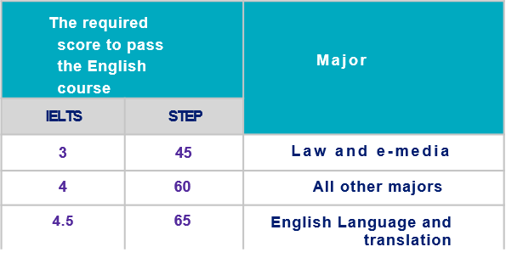

Exams and Grades

Grading System in the Common First Year

First: Passing courses of the Common First Year
Mathematics, Computer, Academic and Communication Skills Courses:
- Distributing grades for courses of mathematics, computer, academic and communication skills is as follows:
With (23) score of the semester project
Semester projects (quizzes, assignments, discussion boards, etc.)
40Grade
100
Total
The required score to pass the English course |  | Major
IELTS | STEP
3 | 45 | Law and Digital Media
4 | 60 | All other majors
4.5 | 65 | English Language and translation
English Course
The English course differs from the rest of the Common First Year courses as it is not calculated in the cumulative GPA, yet it is based on pass/fail grading system. The student must obtain the required score in the (STEP or IELTS) according to the academic program as shown in the following table:
If the student couldn’t obtain the required score, the STEP or IELTS scores will be reduced to the minimum according to the major plus to the semester project score, according to the requirements of the Deanship of the Common First Year.
With (23) score of the semester project
100
Total
Semester projects (quizzes, assignments, discussion boards, etc.)
40Grade
- Students must obtain a minimum score of 60% in order to pass the Common First Year courses.
Final Exam
Mid-term exam
40 Grade
20Grade

Second: Equalization of the Common First Year Courses
If you would like to equalize the courses of the common first year, please visit the Deanship's page on the university website:
https://seu.edu.sa/cfy/ar/courses-equation/equivalence-of-common-first-courses
Semester projects (quizzes, assignments, discussion boards, etc.)
40Grade
Mid-term exam
20Grade
100
Total
Final exam
40Grade

Evaluation and Grading System in the Colleges
Distributing grades for all courses of the colleges is as follows:

E- Exam Systems
Introduction
It is a platform for managing and performing offline and online computer-based exams. The following services are provided:

Student can access to the exam by using their own device securely.

Artificial intelligence technology can be adopted to invigilate exams remotely and ensure its quality.

Extract reports that show students' achievement of learning outcomes and closing the improvement session at the academic program level.
Guideline for online exams via Blackboard Using (SUMADI) browser Secure (Al proctoring with artificial intelligence technology)

Guideline for offline electronic exams (on campus)
For windows
Guideline for offline electronic exams (on campus)
For MAC

Banner
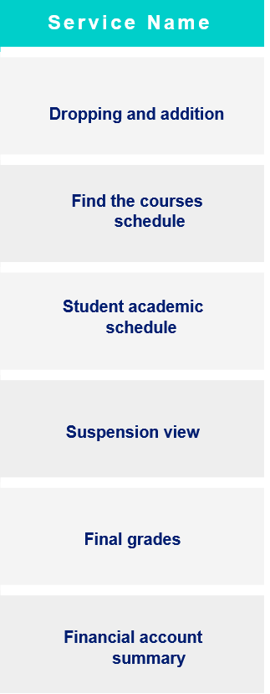
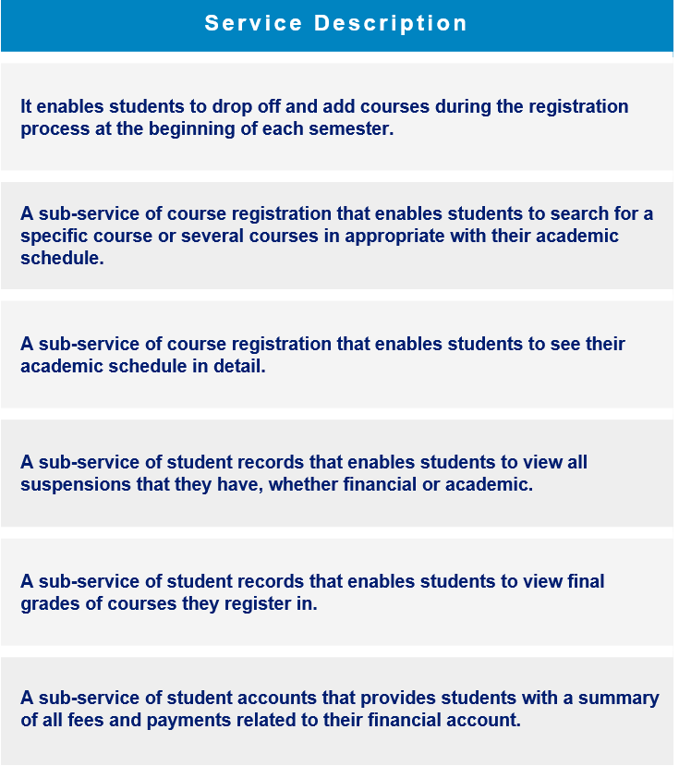
It manages all processes for student and faculty members from the moment of admission until graduation. It contains all student information, including: personal information, study plan, academic statement, admission confirmation, student status, etc.
Key Services

Internship for Undergraduate Programs
The internship course is an important part of any academic program because it provides students with the opportunity to practically apply the knowledge and skills acquired through the academic program. Each college shall establish a process for applying to the internship commensurate with its academic programs to ensure that the required learning outcomes are achieved at the highest standards of quality.
Faculty member Evaluation regarding the student’s performance and progress during the internship period
College evaluation regarding the outcome to be delivered (such as a report or presentation)
30Grade
Internship supervisor Evaluation regarding the student’s performance and progress during the internship period
50Grade
100
Total

Process of applying for internship
₀₁ Minimum credits required to pass
. Rules and requirements for application ₀₂
. Dates and method of application₀₃

Method of evaluation used and the process of distributing grades
Each college sets its own evaluation method to clarify to students the skills, tasks, and training responsibilities required of them from the start of the course. The grades are distributed as follows:
20 Grade

Communication Media with the University
Call center Sanad: It is responsible for receiving inquiries of beneficiaries from potential students or applicants to the university, current students, faculty members and staff of all branches, responding to them, and providing them with all required information.
Given the interest of the university to improve the services provided in accordance with the highest quality standards, the communication media for beneficiaries has been unified.
We are pleased to communicate with you through the following channels:

1. Phone:
Inside Saudi Arabia 199099
Outside Saudi Arabia 00966112613500

2. Chatbot:
For WhatsApp inquiries or suggestions
00966112613500

3. Twitter:
https://twitter.com/SEU_Care
4. Smart Assistant Service
Available on the University's website
https://seu.edu.sa
5. Academic Assistant:
To respond inquiries and problems facing students.
https://eservice.seu.edu.sa/home
Live Help
SAUDI ELECTRONIC UNIVERSITY
2011-1432
وكالة الجامعة للشؤون التعليمية
Vice Rectorate of Academic Affairs

Thank You

13

